James Pens has designed a new lawn care product called the mini-mower and is now considering its processing needs. The variable cost for each mini-mower manufactured is $30. Fixed cost per year is estimated to be $20,000. James is planning to sell each mini-mower at a price of $40. How many products must be sold to break even?

**2,000**

If James sells 5,000 products at the price of $40, what will be the contribution to profit?

**$30,000**

================================================================================

Given the following manufacturing precedence relationships, compute the cycle time per day and the minimum number of workstations assuming eight working hours a day and 400 products need to be produced per day.

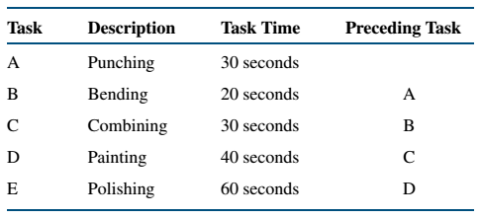

**72 seconds for cycle time per day = 8 * 60 * 60 sec / 400 = 72 seconds**

**3 workstations (180 / 72 = 2.5) or (180 / 60 x 400 / 60 / 8 = 2.5) (ignore order of operations) rounded up**